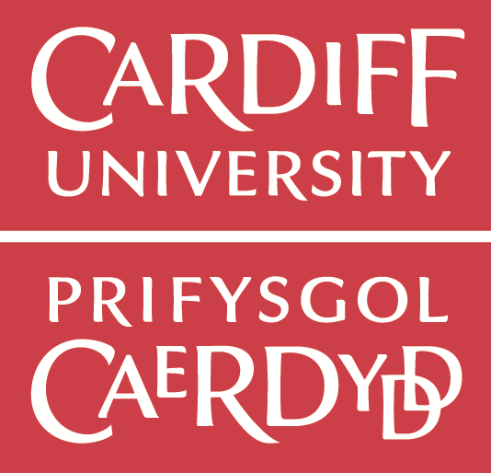
Funded Postgraduate Research Visit Opportunity at the School of Social Sciences, Cardiff University 2017-18

The School of Social Sciences at Cardiff University is an internationally recognised centre of excellence in research and teaching across a range of subject areas including sociology, policy studies, criminology, education and social work. We have a strong commitment to developing programmes of study that benefit from the research expertise and achievements of staff in the School.

We are pleased to offer a short-term (90 days) study and research visit opportunity (funded by the Erasmus+ International Mobility Scheme) for two PhD students from the Department of Sociology at Peking University during the academic year of 2017-18. During your visit you will have the opportunity to work with world-class scholars from the University’s research centres. Applicants should note that this cannot involve any formal joint or co-supervision with the home University: these are visiting appointments only.
As part of your application, you are asked to propose a member of staff (and research group) to host you during your visit. If you do not already have someone in mind, then please refer to information on our Research Themes, Research Groups and members at:
http://www.cardiff.ac.uk/social-sciences/research/themes
http://www.cardiff.ac.uk/social-sciences/research/centres-and-groups

Eligiblity and Language Requirement
All current PhD students in the Department of Sociology are eligible to apply. All our non-English speaking PhD students have achieved an IELTS score 7.0 or above. While this is not a formal requirement, the ability to communicate effectively and fluently in both spoken English and in writing is essential to maximise the benefit of this research visit. Please indicate your English ability in your application.

How to Apply
Postgraduate students who wish to visit the School should submit a short application (max 600 words) that sets out:
- The title and scope of their research;
- The dates of the proposed visit;
- Proposed plan of your work during your stay;
- Why you are a good candidate for this position (linguistically and academically)
- The principle benefit of your research trip to Cardiff
- The benefit of your visit for your professional development

In a separate document please also provide a supporting statement from your supervisor.

What does the funding cover:
Grants are a contribution towards the costs of the planned Erasmus+ mobility project. The grant will likely cover the cost of a return economy flight to the UK (London/Cardiff) from Beijing, as well as a contribution towards inland travel and daily subsistence for 90 days.

Practical Information:
Access to resources and learning materials
Students accepted as Visiting Postgraduate Students may expect:
- access to the University libraries;
- access to the University computing system;
- to be able to attend staff and postgraduate seminars and events; and
- to be able to discuss their work with a designated member of staff

Students accepted as Visiting Postgraduate Students will be expected:
- to acknowledge the School’s contribution in any published work arising from their research where it is appropriate to do so.

Short-term Study Visa
Successful applicants will be offered support in applying for their Short-term Study Visa (if applicable) from the Global Opportunities Team.

Travel Arrangements
Visiting Postgraduate Students will be expected to make all of their own travel arrangements to/from Cardiff.

Payment of Erasmus+ Grant
Upon confirmation of acceptance to study at Cardiff University, and receipt of a fully completed and signed Student Grant Agreement and Learning Agreement, 70% of the total Erasmus+ grant shall be paid directly to the student. At the end of the placement, and once all necessary documenatation and reports have been completed, the final 30% of the grant shall be paid.

Office Accommodation
Visitors will usually make use of desk space & computer access offered by the University’s Libraries. If specific arrangements / facilities beyond this are required, then these should confirmed on the Application Form.

Accommodation/Housing
The Global Opportunities Team will provide advice and information to help find accommodation. Accommodation on University campus is not guaranteed.

Cost of Living
The minimum cost of living as recommended by UK Visas and Immigration (UKVI) for studying outside London is £1,015 per month. These estimates include accommodation, food, books, clothes, travel, telephone and social expenses. Our living costs calculator can help you decide what your average living costs would look like based on international student expenditure at Cardiff University.http://www.cardiff.ac.uk/study/campus-life/living-costs

Selection Process:
The Selection Panel is made up of two senior academics from the School of Social Sciences at Cardiff including the Director of Postgraduate Research, and one faculty member from your department (usually the Director of Graduate Programme or his/her nominee). Shortlisted candidates may be requested to attend a short interview via Skype conducted by the panel.

Post-Award Requirement: Visiting students are required to submit a short report (no more than 1000 words) reflecting on their experiences at Cardiff, which may be used for the School’s website to inform future visiting scholars.

Closing Date: Friday 7th April 2017. Applications are particularly welcome for a visit during the months of September – December 2017. Successful applicants will normally be notified within a month of the receipt of the applications.

CARDIFF UNIVERSITY - SCHOOL OF SOCIAL SCIENCES:
Application for Visiting Status – Postgraduate Research Students

Applicant Details (Please attach Your Curriculum Vitae & Your Supervisor’s Statement)
Name:
Institution:
Address:
Email Address:

IELTS Score or equivalent:
Proposed Duration of Visit:
Proposed Start & End Dates of Visit: | Anticipated visits should take place between May – July 2017.
Funding Source:  *Please note the grant amount may be subject to fluctuation and will be confirmed upon successful application. | Erasmus+ ICM Grant:  €1100 Travel grant  €2550 Individual support grant (for 90 days exactly)
Objectives, Contacts and Facilities
Objectives of Visit:
Title and Scope of Research:
Benefit to Applicant Arising from Visit:

Contribution to School of Social Sciences:
Academic Colleagues & Research Group(s) you have made contact with in the School:

Special Arrangements / Facilities Required:
(Visitors will usually make use of desk space & computer access offered by the University’s Libraries)

Please submit completed application forms to: axelsena@cardiff.ac.uk by 7th April 2017

